**First React With JSX**

Create a new React project using create-react-app. Then, change the App.js component so that is shows us a page that resembles the following wireframe.

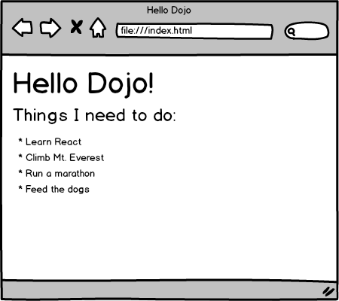

* Top of Form
  + Create a create-react-app app
  + Use JSX to display "Hello Dojo"
  + Use JSX to display a todo list
* Bottom of Form